High Level Design (HLD)
Issue Drug to Patient Demo Project

Table of Contents
1. System Overview
2. High-Level Architecture
3. Core Services
4. Key Data Flows
5. UI Design & Screenshots

1. System Overview
This Demo project is a distributed system designed to manage drug issuance to patients while maintaining real-time inventory accuracy. It addresses the critical need for consistency between physical stock and digital records in a high-concurrency hospital environment.

1.1 Key Features
- Distributed Transactions (Saga Pattern): Ensures data consistency across Orchestrator, Inventory, and Issue services.
- Real-time Stock Updates: Immediate reservation and deduction of stock to prevent overissue.
- Optimistic Locking: Prevents race conditions when multiple users access the same batch simultaneously.

2. High-Level Architecture
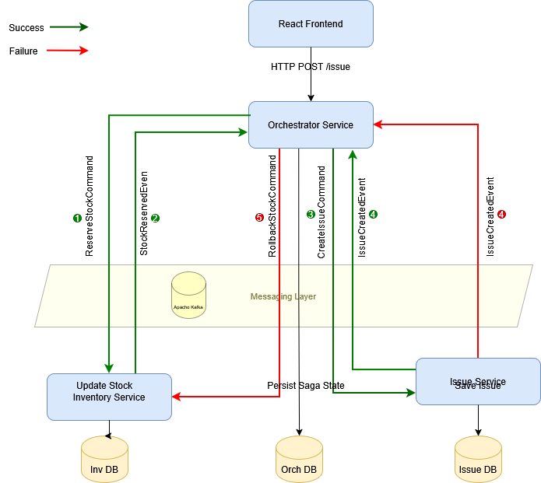

2.1 Components
Component | Description
Frontend | React.js Single Page Application acting as the user interface.
API Gateway / Orchestrator | Central service managing transaction flows.
Inventory Service | Manages drug stock, batches, and reservations.
Issue Service | Handles issue to patients’ records.
Apache Kafka | Message broker for asynchronous communication.
PostgreSQL | Relational database (Service-per-DB  pattern).

2.2 Flow

2.2.1 Step 0 – Client Request
React Frontend → Orchestrator Service
- Client sends HTTP POST /issue
- Request contains item, quantity, patient/user details
- Orchestrator starts a new saga instance
- Initial saga state is persisted in Orch DB

2.2.2 Step 1 – Reserve Stock Command (①)
Orchestrator → Kafka → Inventory Service
- Orchestrator publishes ReserveStockCommand
- Command contains itemId, batchNo, quantity, sagaId
- Purpose: request stock reservation before issuing

2.2.3 Step 2 – Stock Reserved Event (② – Success)
Inventory Service → Kafka → Orchestrator
- Inventory service performs atomic native SQL update
  - Checks available quantity
  - Deducts quantity in a single transaction
- On success, emits StockReservedEvent
- Orchestrator:
  - Consumes event
  - Updates saga state in Orch DB to STOCK_RESERVED

2.2.4 Step 3 – Create Issue Command (③)
Orchestrator → Kafka → Issue Service
- After stock reservation success
- Orchestrator publishes CreateIssueCommand
- Command includes sagaId, item details, quantity, patient/user info

2.2.5 Step 4 – Issue Created Event (④ – Success)
Issue Service → Kafka → Orchestrator
- Issue service saves issue details in Issue DB
- On successful persistence:
  - Emits IssueCreatedEvent
- Orchestrator:
  - Marks saga as COMPLETED
  - Returns success response to client

2.2.6 Failure Path A – Stock Reservation Failed
Inventory Service → Kafka → Orchestrator
- If insufficient stock or DB failure
- Inventory emits StockReservationFailedEvent
- Orchestrator:
  - Marks saga as FAILED
  - No further commands are sent
  - Error response returned to client

2.2.7 Failure Path B – Issue Creation Failed (⑤)
Issue Service → Kafka → Orchestrator
- Issue service fails while saving issue
- Emits IssueCreateFailedEvent
- Orchestrator:
  - Updates saga state to ISSUE_FAILED
  - Publishes RollbackStockCommand

2.2.8 Step 5 – Rollback Stock Command (⑤ – Compensation)
Orchestrator → Kafka → Inventory Service
- Compensation step
- Inventory service adds back the reserved quantity
- Uses atomic SQL update to restore stock
- Ensures system consistency

2.2.9 Step 6 – Kafka fails
Inventory/Issue Service → X Kafka
- The Inventory/Issue Service has successfully committed to Inventory/Issue DB.
- The attempt to publish StockReservedEvent/IssueCreatedEvent to Kafka fails (Connection Refused / Timeout).
  - The Java process catches the exception.
Case A: Actions "Retry within Timeout" (Transient Glitch)
- If the connection restores within the timeout, the StockReservedEvent/ IssueCreatedEvent is successfully sent.
- The Consumer finishes execution and commits the offset.
Case B: Actions "After Timeout" (Broker Down / Persistent Failure)
- The Broker remains down longer than the Producer's timeout config.
- The Consumer THROW this exception back to the container. DO NOT swallow it.
- Kafka does NOT commit the offset for the ReserveStockCommand/ CreateIssueCommand.
- When the Broker comes back up, Kafka Redelivers the command.
- The Idempotency logic detects the duplicate TransactionID/IssueID and skips the DB update, only retrying the Event Publish.

3. Core Services

3.1 Orchestrator Service
Acts as the Coordinator. It initiates the “Issue Drug”, coordinates interactions with the Issue Service, tracks the transaction state from START to SUCCESS or FAILURE, and orchestrates the required compensating (rollback) actions whenever any step fails.

3.2 Inventory Service
Responsible for maintaining the integrity of stock data. It listens for stock reservation commands, updates the Drug current stock details table, and uses atomic native SQL statements to prevent race conditions and ensure consistency without requiring explicit locking.

3.3 Issue-to-Patient Service
Finalizes the transaction by saving the drug issue details permanently, while ensuring data integrity by handling any system failures with automatic rollbacks.

4. UI Design & Screenshots

4.1 Inventory Management
UI for monitor real-time stock levels, track batch expirations, and manage inventory across stores to prevent shortage
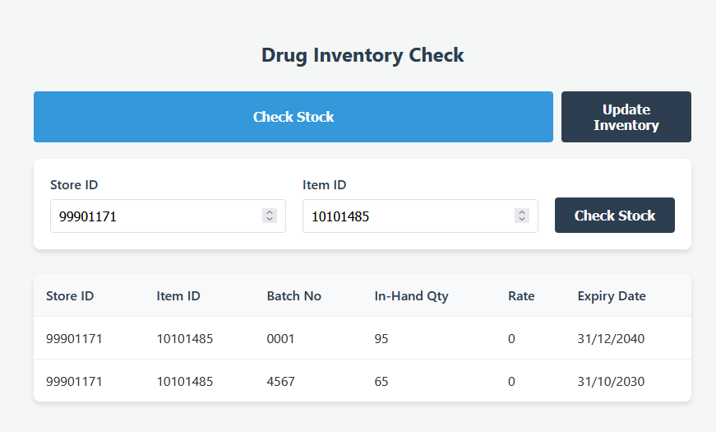

4.2 Patient Issue Form
The primary screen for issuing drugs to patients, selecting batches, and submitting the request.
